RECORDING REQUESTED BY:

(Mail Recording to:)

**Charles P. Watson**

180 Main Street

P.O. Box 1956

Chester, CA 96020

(530) 258-4228

______________________________________________

**Placer Mining Claim Notice of Location**

1. The name of this Placer Mining Claim is: **Black Jack**

2. The date of this location as posted on said claim is: **July 20, 2015**

3. The discovery monument is described as a wooden post painted red and secured in a mound of stone

with an attached plastic bottle that contains the location notice.

4. The general course of the placer deposit is north to south.

5. The Placer Mining Claim is in **Plumas County**, Californiaand contains **±20 acres**.

6. The U.S. Public Land Survey and the legal subdivision including Aliquot Part Description is:

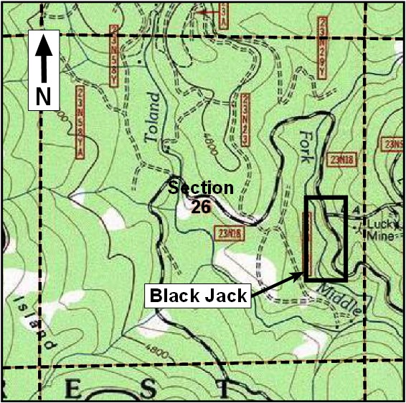

**W1/2 E1/2 NE1/4 SE1/4 and the**

**E1/2 W1/2 NE1/4 SE1/4 of Section 26,**

**Township 23N, Range 6E, M.D.M.**

7. Claim Location Map:

8. Locators of this Placer Claim:

Charles P. Watson- P.O. Box 1956, Chester, CA 96020

___________________________________________________

9. Signed by Charles P. Watson on **July 20, 2015**.