RECORDING REQUESTED BY:
(Mail Recording to:)

Charles Watson
Advanced Geologic Exploration, Inc.
PO Box 1956
Chester, CA 96020
______________________________________________
Placer Mining Claim Certificate of Location

1. The name of this Placer Mining Claim is: LVW 14
2. The date of this location as posted on said claim is: ______________________
3. The discovery monument is described as a wooden post painted red and secured in a mound of stone
with an attached plastic bottle that contains the location notice.
4. The general course of the placer deposit is north to south.
5. The Placer Mining Claim is in Esmeralda County, Nevada and contains ±20 acres.
6. The U.S. Public Land Survey and the legal subdivision including Aliquot Part Description is:

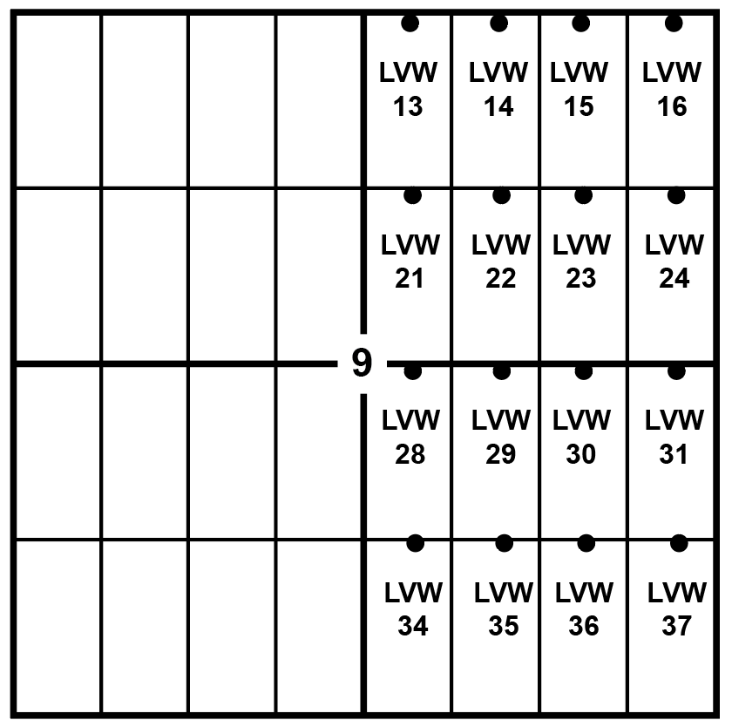
E1/2 NW1/4 NE1/4 of Section, 9
Township 6S, Range 41E, M.D.M.

7. Claim Location Map:

8. Locators of this Placer Claim:

Charles Watson
Advanced Geologic Exploration, Inc.
PO Box 1956
Chester, CA 96020

9. Signed by Charles P. Watson, Advanced Geologic __________________________________________.

